DEALS TO NEWARK, NJ

Newark, just eight miles from Manhattan, is the Garden State’s largest metropolis. This city offers many diverse experiences, including the largest collection of cherry blossoms in the nation and one of the country’s largest performing arts centers. Book a trip to Newark via Newark International Airport on Virgin America. Live it up at 35,000 feet with WiFi, on-demand entertainment, and more on every flight.

(MARKET IMAGE HERE)

Find Deals From These Cities

INSERT FARE GRID FROM / TO Version (if available!)

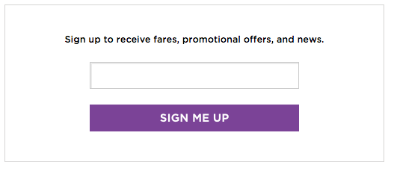

Top Things To Do in Newark

Be sure to try one of the highly recommended activities below if you’re looking for things to do in Newark, NJ.

* Treat yourself to a grand performance and head to the New Jersey Performing Arts Center (NJPAC), one of the largest and most glamorous performing arts venues in the United States.
* Branch Brook Park is beautiful all year round but is a must-see in the spring, when its stunning collection of over 4,000 cherry blossoms are on display for everyone’s enjoyment.
* Dine at a restaurant in the renowned Ironbound District for some of the best Brazilian, Portuguese, and Spanish fare around.

Travel Tips and Resources

[Must-Dos in Newark](http://www.visitnj.org/city/newark)

[Newark Hotels](http://www.tripadvisor.com/Hotels-g46671-Newark_New_Jersey-Hotels.html)

[Newark Restaurants](http://www.movoto.com/guide/newark-nj/newark-restaurants/)

[Newark Shopping Guidehttp://www.newarkhappening.com/things-to-do/shopping](http://www.newarkhappening.com/things-to-do/shopping)

[Newark Nightlife and Entertainmenthttp://www.newarkhappening.com/things-to-do/nightlife](http://www.newarkhappening.com/things-to-do/nightlife)

[Newark Travel Tips](http://www.tripadvisor.com/Tourism-g46671-Newark_New_Jersey-Vacations.html)

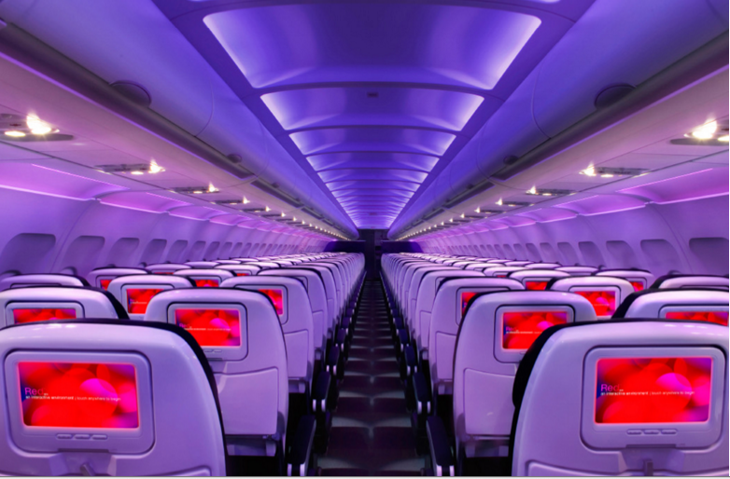

Main Cabin Main Cabin Select First Class

(add links to Cabin Class Pages)

Ready. Set. Fly.

Book your Mood-lit Ride to Newark.

Looking for flights to Newark, NJ? Whether you’ll be visiting for business or personal reasons, you’ll want to book your flight to Newark Liberty International with Virgin America. Every guest receives an exceptional level of customer service from our friendly, knowledgeable, and accommodating inflight team. When you fly with us, you’ll feel at home with all of our fabulous amenities, which include relaxing mood-lit lighting, on-demand food, and unbelievably comfortable leather seats.

Take a Virtual Tour

Add Terms & Conditions